Bird Nest Box Results for 2017 (some sponsored)

* Due to circumstances beyond our control it was not possible to conduct bird nest box survey covering 2014.
* Photographs noted in 2016 & 2017 may be found on the ‘Biodiversity Records & Image Galley of Maple Lodge Nature Reserve’ website (Photo Gallery page) with some also on the Maple Lodge Facebook Forum.

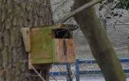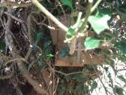Nest Box 1 (Until end of 2017: GPS – N5137288 W030163) Was located 20 yards after the Notice Board on Ivy covered tree stump, wire netting over box entrance, currently not sponsored - 2008: Great/Blue Tits nested/bred (4 died in the nest). 2009 & 2010: Empty. 2011: Probably occupied/used by Robin. 2012: Possibly occupied. 2013: Tit species. 2014: No survey. 2015: Unable to clearly see due to wire netting. 2016: Some leaves but no nest. 2017: Box not used. The tree stump is now rotted, so box moved in Jan 2018 to same tree as Treecreeper Nest Box O, i.e.:

Nest Box 1 (After 2017: (GPS - N5137296 W030168) Located on tree opposite path to bee hives – 2018:

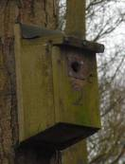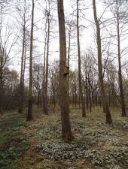
Nest Box 2 (GPS - N5137278 W030161) Located in the Plantation, sponsored by Judith Passingham - 2008: Nesting attempted. 2009: Predated. Entrance hole has been pecked and thus made larger. 2010: Empty. 2011 & 2012: Failed attempt. (New front fitted March 2013). 2013: Nesting material. 2014: No survey. 2015: Cupped Tit nest – no egg shells, possibly used. 2016: Tit nest but no sign of a cup so probably not used. 2017: Cupped Tit nest – some dropping and feathers, probably successful.

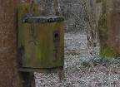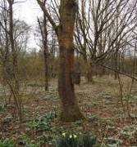Nest Box 3 (GPS - N5137254 W030136) Located approx 10 yards from footpath edge of the Plantation, sponsored by tbc - 2010: Entrance hole pecked wide. Box content not checked. 2011: Tit box utilised but predated. 2012: Empty. (Refurbished box fitted low on tree March 2013). 2013: Nesting material only. 2014: No survey. 2015: Evidence of bird nesting. 2016: Gary Armstrong photographed Great Tit entering box 2nd June. Cupped nest present, possibly successful. [Roof later secured with a fixing tie]. 2017: Cupped nest present, possibly successful. [Mouldy Roof to be replaced and waterproof cover put over hinge area.]

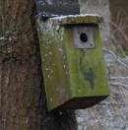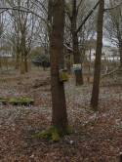
Nest Box 4 (GPS - N5137256 W030150) Located at right side of the Plantation, near the pathway, sponsored by Paul Ward - 2008: Great/Blue Tits nested and possibly bred. 2009: Great/Blue Tits nested and possibly bred. 2010: Empty. 2011 & 2012: Nesting attempted - probably successfully. 2013: 1 brood of Tit species. 2014: No survey but Great Tit recorded taking food into box in early May – a Blue Tit was photographed prospecting this box on March 12 2014 by Keith Pursall (Photo is on Maple Lodge Web Site gallery (under ‘Boxes’) and on the Maple Lodge Facebook Forum). 2015: Great Tit – 1 broken egg shell and 3 unbroken eggs. 2016: Blue Tit reported using box on Open Weekend (14th and 15th May). Successful usage. 2017: Great Tit (1 exiting nest box 4 on 29th Apr). Cupped nest present, probably successful.

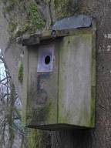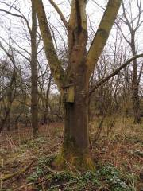
Nest Box 5 (GPS – N5137269 W030196) Located at the back left corner of the Plantation near yellow bench, sponsored by Jill Kempster - 2008 and 2009: Nesting attempted but predated. Entrance hole has been pecked and thus made much larger (Plastic Plate now fitted - March 2013). 2010: Empty. 2011: Nesting failed - 5 Tit eggs. 2012: Empty. 2013: Not checked. 2014: No survey. 2015: Box found on ground, no nest. Now put back on tree about 6 feet up. 2016: Box is in good condition. Mossy nesting material but no clear sign of nesting. 2017: As 2016 - Mossy nesting material but no clear sign of nesting. Waterproof cover out over hinge area to prevent water getting into box for 2018.

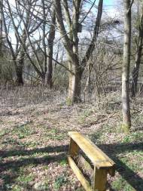Nest Box 6 (GPS - N5137242 W030098) Located high (about 14 feet up) on tree at the back of the Plantation, sponsored by Jill Kempster - 2008 & 2009: Empty. Entrance hole has been pecked a bit wider (Plastic Plate now fitted - March 2013). 2010: Empty. 2011: Successful brooding. 2012: Successful brooding. White egg shell (Blue Tit?) remains. 2013: Not checked. 2014: No survey. 2015: Nest found, probably successful - 3 skeletons found – sizeable, possible Great Tits (Photo by Adrian Lee may be found on Web Site gallery and Facebook forum). 2016: Box ok. High up and not looked into this year. Blue Tit reported using box on 8th May. 2017: Needs longer ladder to survey – TO DO.
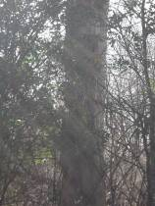Nest Box 7 (GPS - N51373?? W0301??) Located by the Pond / Old feeding site / Bandstand area, sponsored by Mr & Mrs Turner - 2008: Blue Tits nested and bred. 2009: Evidence of Blue Tit nesting. Entrance hole pecked a little. 2010: Roosting only, bird type unknown - nesting material inside may have been trampled down flat by maturing chicks. 2011: Empty. Not checked. 2013: Not checked. 2014: No survey but Great Tit photographed (see Web Site gallery under ‘boxes’) at entrance of nest box on dead tree by the pond in March. 2015: Cupped Tit nest, no shells. 2016: Successful nesting. Martin Parr noted (7th May) Great Tits feeding young and removing faecal sacs. Colin Rowe photographed Great Tit parents in and out of box on 7th May.

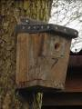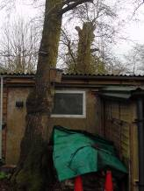2017: Tree has fallen and box is smashed. Box replaced and re-sited on Woodshed for 2018.

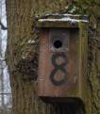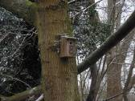
Nest Box 8 (GPS - N5137263 W030181) Located by the junction of the pathways to the Shell and Rotunda hides, sponsored by Mr & Mrs Stevens - 2008 and 2009: Nesting attempted (by Blue or Great Tits). 2010: Blue Tits bred - two eggs left. 2011 & 2012: Failed nesting attempt. 2013: Nesting material only. 2014: No survey. 2015: Evidence of nesting. No egg shells. 2016: Successful nesting. Blue Tit reported using box on Open Weekend (14th and 15th May). Blue Tit seen at this box on 28th May. Gary Armstrong photographed Blue Tit exiting box 2nd June. 2017: Distinct cupped Tit Nest – probably successful.

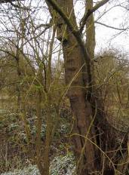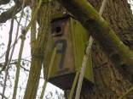
Nest Box 9 (GPS - N5137108 W030180) Located by the Sluice (left of the bridge), currently not sponsored - 2008: Great/Blue Tits nested. 2009: Empty. Great Tits were seen using it. Entrance hole OK. 2010: Great Tits bred. 2011: Nesting failed. Hole needs repairing (slight damage) (Tin Plate now fitted - March 2013). 2012: Nesting attempted. 2013: Nesting material only. 2014: No survey. 2015: No nesting evidence. 2016: Great Tit seen at this box on 21st May. Possibly successful – small fragments of egg shell found in the nest. 2017: Great Tit (feeding chicks in Nest Box 9 on 20th May). Nesting confirmed. Cupped nest with one Tit skeleton remaining.

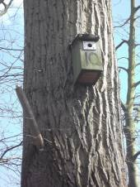
Nest Box 10 (GPS - N5137129 W030162) Located 30 yards before the Sluice Hide, currently not sponsored - 2008: Not recorded. 2009: Blue Tits nested/bred (2 died in the nest). Entrance hole OK. 2010: Roosting only - nesting material inside may have been trampled down flat by maturing chicks. 2011: Empty. 2012: A good nest with broken egg shells but no feathers. (Wire catch on lid replaced March 2013). 2013: Nesting material only. 2014: No survey. 2015: No nesting. Box damaged, removed early in year and replaced with Nest Box 10a lower on same tree:

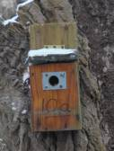
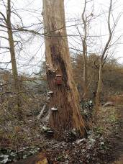Nest Box 10a (GPS - N5137129 W030162) – Replacement of Nest Box 10 in 2015. Located 30 yards before the Sluice Hide, currently not sponsored. 2015: Great Tit successfully nested. 1 unbroken egg left. 2016: Great Tit successfully nested. 2017: Definite cupped nest. Probably successful.

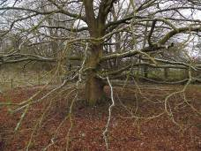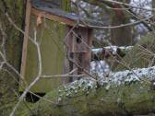
Nest Box 11 (GPS - N5137??? W030???). Located on Oak Tree by the Barn Owl Flower Meadow. Sponsored by Ann and Michael Dent. 2008: Great/Blue Tits nested. 2009: Empty. Entrance hole OK. 2010: Empty. 2011: Successful. 1 body. 2012: Successful. Eggs shells. 2013: Nesting material only. 2014: No survey. 2015: No nest, roof damaged. Removed for roof to be replaced and box to be put up for next year (Done Feb 2016). 2016: Great Tit seen at this box on 4th June. Nesting successful. 1 skeleton found. 2017: Great Tit (in Nest Box 11 feeding young on 12th May). Successful – cupped nest.

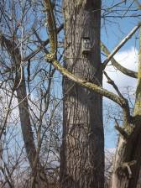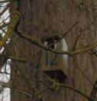
Nest Box 12 (GPS - N5137123 W030176) Located high on tree by the Kingfisher Hide near Sluice, sponsored by Maddie Jones - 2008: Wren nested. 2009: Great Tits nested/bred (3 died in the nest). Entrance hole OK. 2010: 4 dead Tits (species?) & 1 egg. 2011: Successful - Great Tits. 2012: A good nest but with no egg shells or feathers present. 2013: Damaged Box to be repaired. 2014: No survey. 2015: No nesting. Box damaged and should be removed. 2016: Box still present (now with large pecked entrance hole) – still (2018) to be removed. Replaced with Nest Box 12a lower on same tree:
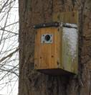
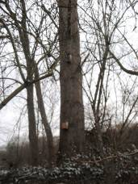Nest Box 12a (GPS - N5137123 W030176) – Replacement of Nest Box 12 in 2015. Located low on tree by the Kingfisher Hide near Sluice, sponsored by Maddie Jones. 2015: Moss only in box – no nesting. 2016: Tit nest found with feathers and egg shells so probably successful. 2017: Good Tit nest. Probably successful.

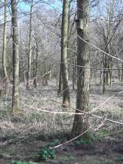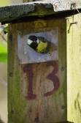
Nest Box 13 (GPS - N5137273 W030166) Located at the footpath edge of the Plantation, sponsored by tbc - New box 2009: Empty. (Entrance hole pecked wide - repaired March 2013). 2010: Empty. 2011: Nesting (1 dead Great Tit). 2012: Used by Blue/Great Tits - one white and brown speckled egg left in nest. 2013: Empty. 2014: No survey. 2015: No evidence of nesting, however Great Tit recorded using box on 4th May. 2016: Empty. Box and entrance hole ok. 2017: Evidence of a Tit nest. Photo of Great Tit coming out 11th April. Box has now fallen and the lid is missing – In Workshop to be repaired and put back up. 2018: Box repaired in Jan and put up on original tree but lower (about six foot from the ground).

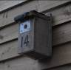
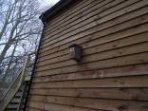Nest Box 14 (GPS - N5137227 W030215) Located on the Double-decker Hide, sponsored by Geoff Lapworth - 2008: Blue Tits nested/bred (4 died in the nest). 2009: Empty. Entrance hole pecked. 2010: Tits nested but deserted 8 eggs. 2011 & 2012: Successfully used by Great Tits. 1 creamy white brown speckled egg in nest. 2013: Nesting material only. 2014: No survey but Great Tit recorded and photographed taking food into box in mid-May and was photographed exiting the hole c May 19th 2014 by Keith Pursall (Photo may be found on the Maple Lodge Web Site gallery (under ‘Boxes’) and on the Maple Lodge Facebook Forum). 2015: Moss in Box but no cup in moss. No reported sightings of usage. 2016: Great Tit reported using box on 8th May. Cupped nest found – probably successful nesting. Side of box has sign of Woodpecker activity, so had to be subsequently repaired. 2017: No nesting record. Repaired / replaced late 2017 and located onto the new Double Decker hide for usage next year.

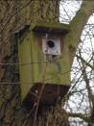
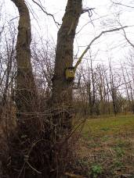Nest Box 15 (GPS - N5137222 W030189) Located at back of the Plantation, sponsored by Jill Lynch and Diane - 2008: Nesting attempted. 2009: Evidence of nesting and predation. Entrance hole has been pecked and currently very large. 2010: Empty. 2011: Failed attempt. Box found on ground - to be put up for next year. 2012: Empty - replaced on tree at back of plantation near bench. 2013: Empty. 2014: No survey. 2015: Empty. 2016: Empty, except for bird droppings. Box is ok. 2017: Tit sp (feeding in Nest Box 15 on 20th May). Nest looked good, possibly successful. At time of survey (Jan 6 2018, a freshly dead adult Wren was found on the nest, possibly perished whilst roosting during a recent cold spell. Box repaired to prevent damp for 2018.

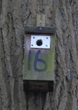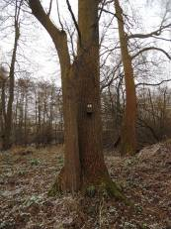Nest Box 16 (GPS - N5137221 W030187) Located towards the Double-decker Hide (near the bat boxes), sponsored by Keith & Jan Pursall - 2008: Nesting attempted but predated. 2009: Tits nested (1 egg left - Blue Tit?). Entrance hole is OK. 2010: 2 dead Tits. 2011: Success but 3 chicks and 1 adult Great Tit died. 2012: Failed attempt. 2013: Empty. 2014: No survey. 2015: This was checked when the nearby bat boxes were checked and as it was damaged it was taken down. 2016: Old box replaced with new box this year. No sign of usage. 2017: Flat nest with no cup. Cobwebs. Probably not successful.

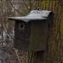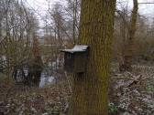Nest Box 17 (GPS - N5137219 W030185) - Near to Nest Box 16. 2012: Successful Tit nest. 2013: Empty. 2014: No survey. 2015: Tits possibly nested. No shells. 2016: Nesting attempted, possibly partially successful – 1 egg and 2 unidentified Tit skeletons found. 2017: Empty.

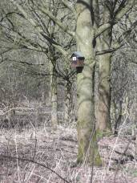Nest Box 18 (GPS - N5137234 W030129) Located front of Plantation facing pathway towards Teal Hide, sponsored by Sue Walker. Box is sealed so not possible to check contents. 2010: Used by Tits. 2011 & 2012: Observed being used by Tits. 2013: Unable to access box. 2014: No survey. NB: Undated but pre 2015 photos on the Maple Lodge Web Site gallery page (under ‘Boxes’) show a Wren entering this box to possibly roost. 2015: Replaced with ‘accessible’ Nest Box 18a as below:

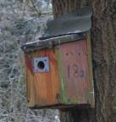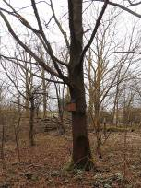Nest Box 18a (GPS - N5137233 W030132) Replacement of Nest Box 18 in 2015. Located front of Plantation facing pathway towards Teal Hide, sponsored by Sue Walker. 2015: Nest started but not finished. 2016: Great Tit reported using box on Open Weekend (14th and 15th May). Gary Armstrong photographed Great Tit taking food to box 2nd June. No eggs or skeletons found in cupped nest so probably fully successful. 2017: Some droppings and traces of Tit feathers in cupped nest so possibly successful.

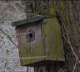
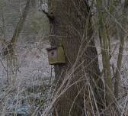Nest Box 19 (GPS - N5137229 W030263) Located opposite the Sanctuary Hide (moved from near the Rotunda Hide in 2011), sponsored by Ken Baker - 2008: Blue Tits nested/bred (3 died in the nest). 2009 & 2010: Empty (Hole pecked). 2011: Successful nesting - Great Tits. 2012: Empty. (New box sited low, opposite Sanctuary Hide - March 2013). 2013: Nesting material – box occupied by 2 Shrews at time of survey. 2014: No survey but Blue Tits recorded using this box in mid-March. Blue Tit photographed looking out of the entrance hole on 14th Mar 2014 by Jackie Brunt (Photo is on Maple Lodge Web Site gallery (under ‘Boxes’) and on the Maple Lodge Facebook Forum. 2015: Mossy nest possibly used by Tits. 2016: Blue Tit reported checking box on 26th Feb. Good nest found with a few feathers – possibly successful. 2017: Cupped nest. Possibly successful.

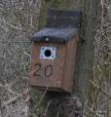
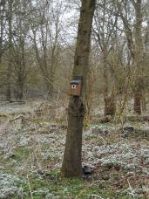Nest Box 20 (GPS - N5137260 W030148) (for wren or robin sized birds). Located approx 5 yards from footpath, opposite the start of the Plantation, sponsored by tbc - 2010: Box content not checked. 2011: Tit sp probably nested. 2012: Tit nest. (Hole still to repair). 2013: Nesting material. 2014: No survey. 2015: An old nest removed. 2016: Leaves only. ‘Woodpeckered’ hole still to repair. 2017: No nest.

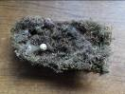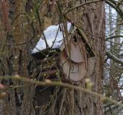Nest Box 21 (GPS - N5137256 W030183). Located by the junction of the pathways to the Teal and Rotunda hides – added in 2015 near to box 8. Approx six feet up. No current sponsor. 2015: Evidence of nesting with one Great Tit egg remaining. 2016: Empty. 2017: Blue Tit (at nest box 21 on 24th Mar). Cupped nest and a few Tit feathers - possibly successful.

Nest Box 22. There is no Nest Box 22 (yet)

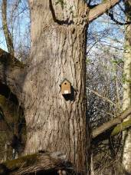Nest Box 23 (GPS – N??????? W???????). Tit box located on right of path, between Wood Shed and T Junction in 2016. Approx eight feet up on Poplar. No current sponsor. 2016: No easy access to contents of box as angular roof is fixed. No reported usage. 2017: Can not access the box but a Great Tit was seen at nest box 23 on 19th Mar.

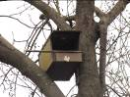
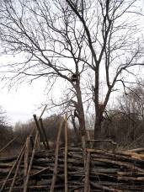Nest Box 24 (GPS – N??????? W???????). Kestrel box located facing Barn Owl Meadow in 2016. Approx twelve feet up. No current sponsor. 2016: Nothing reported. 2017: Nothing reported.

Nest Box 25 - Duck Box (GPS – N??????? W???????). New for 2018. Currently stored near Lean-to. 2018: Box to be sited on the Reserve.

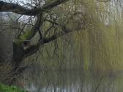
Nest Box 26 - Duck Box (GPS – N??????? W???????). New for 2018. Currently stored near Lean-to and now located on Willow tree on left of Clubhouse Lake (as viewed from Clubhouse hide).

Nest Box 27 – Owl or Kestrel Box (GPS – N??????? W???????). New for 2018. Currently stored near Lean-to. 2018: Box to be sited on the Reserve.

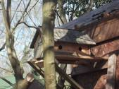Nest Box 57 (Until 2017: GPS – N5137322 W030187) Replaced Nest Box K which was removed in 2011. Nest Box 57 is a new 4 chamber (House Sparrow?) box sited on far end of Lean-to in March 2013. Not currently sponsored. 2013: Empty. 2014: No survey. 2015: All chambers empty. 2016: No usage - House Sparrows are very rarely recorded on the reserve these days but are present in Maple Lodge Close, so relocating the box for 2017 nearer to where they are seen.

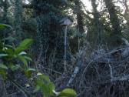 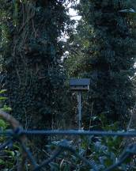2017: Relocated to corner of Reserve near inlet stream and visible from Maple Lodge Close and Social Club car park. (From 2017: GPS – N51????? W03????). Nothing reported but Survey still to do.

Other Nest Box Results - (None currently sponsored, and not actually all lettered):

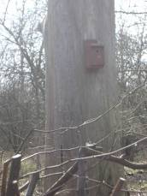Nest Box A (GPS - N5137310 W030177) (Removed 2011 / Replaced with ex donations box 2013). Was located near Notice Board and bleached tree, now on bleached tree. 2008: Not recorded. 2009: Empty. Entrance hole damaged. 2010: Empty. 2011: Box not useable - removed. 2013: New box sited on bleached tree. Unable to check. 2014: No survey but photo (on Web Site gallery) taken by Martin Parr of Blue Tit at box entrance in 2014. 2015: Hole slightly damaged. Lid is screwed down, so requires screwdrivers to open it. Tit nest was found. Probably successful - A Blue Tit was seen coming out of the box on 4th April and one photographed by Keith Pursall c May 19th 2015 –Photo is on Maple Lodge Web Site gallery (under ‘Boxes’) and on the Maple Lodge Facebook Forum. 2016: Successful – feathers in nest and skeleton. Martin Parr photographed a Blue Tit at box on 15th Feb. Keith Pursall noted (31st March) a Blue Tit was making regular visits to this box (but not when Keith was waiting for it with his camera). Ken Law photographed box being used by Blue Tits on 22nd May. [Box left in situ but the part Woodpecker pecked entrance hole to be repaired]. 2017: Great Tit (at nest box A on 18th Mar). Tree has now fallen and box smashed:

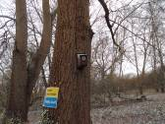Nest Box A (GPS - N51373?? W0301??). Replacement box A built and re-sited on the left towards the bee hives for 2018.

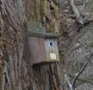
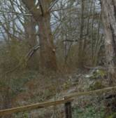Nest Box B (GPS - N5137166 W030186) Located 15 yards left of Teal Hide, approx 15 feet up on tree. 2008: Not recorded. 2009: Failed clutch of 6 Great Tit (?) eggs. 2010: Empty. 2011: Good nest. Probably successful. 2012: Probably successful - two Great Tit eggs remained. 2013: Empty. 2014: No survey. 2015: Tit Nest – possibly successful. Roof has a large hole so should be repaired. 2016: Roof has been repaired. Tit nest found, but in very clean condition no possibly not used. 2017: Great Tit (in Nest Box B feeding young on 12th May). Successful nesting confirmed.

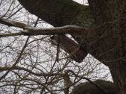Owl Nest Box C1 (GPS – N5137119 W030285) Located on old Long Hedge Oak Tree - an older box than below C2 box. 2008: Not recorded. 2009: Not checked but believed unused. 2010 & 2011 & 2012 & 2013: Empty / unused. 2014: No survey. 2015: In state of disrepair – should be removed. 2016: As per 2015. 2017: As per 2015/16.

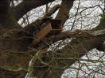
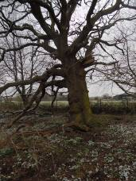Owl Nest Box C2 (GPS - N5137115 W030283) Located on old Long Hedge Oak Tree - a newer box (start date of 2013 to be checked) than above C1 box. 2013: Empty. 2014: No survey. 2015: Unused - Nothing observed using it. 2016: As per last year. 2017: Nothing observed using it. However, 2 decomposed squirrels were found inside.

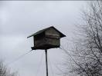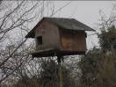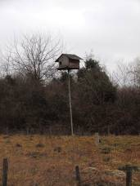
Barn Owl Nest Box D (GPS - N5137108 W030217) Located on pole in Wildflower Meadow. 2008: Barn Owls. 2009: Not checked but no sign of breeding recorded. 2010: 2 Barn Owl chicks reared. 2011 & 2012: Checked March 2013 - had 1" of droppings inside. Stock Dove maybe? (One seen leaving a couple of times). 2014: No survey but occupied in July by Barn Owls with young suspected in August and two juveniles recorded in September. 2015: No reported usage this year, however a Stock Dove was recorded on 4th April in this box. 2016: Although a Barn Owl was reported in May and two in August, there is no confirmation this box was used for any nesting. 2017: Too high to look inside this year. However, no reported usage during 2017.

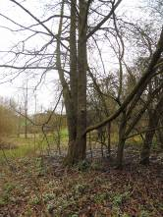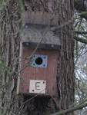
Nest Box E (GPS - N5137081 W030181) Tit box located in the Paddock. 2008: Not recorded. 2009: A damp nest (Blue Tit?). Entrance hole pecked. 2010: Empty. 2011: Tits nested successfully. 2012: Tit nest with droppings. Possibly successful. 2013: Empty. Entrance hole picked at – to repair. 2014: No survey. 2015: Damaged beyond repair – taken down. To be replaced. 2016: Replaced with new box E. Nest did contain fur (possibly from squirrel?) but had no sign of eggs or feathers. 2017: Incomplete nest. Successful nesting unlikely.

Little Owl Nest Box F (GPS - N5137063 W030212) Located by Lynsters Hide. 2008: Not recorded. 2009: Full of dead leaves - possibly by Squirrels. 2010: Empty. 2011: Just a few flattened leaves - not a nest. 2012: Box missing! - replaced on different nearby tree 2013 (as below ->):
Little Owl, Stock Dove or Parakeet etc Nest Box F (GPS - N5137051 W030219) Located on tree near Lynsters Hide. 2013: New Box F missing?? 2014: No survey. 2015: Damaged beyond repair – to be taken down and replaced. 2016: Box not found. 2017: Just the front and two sides found on the ground – Build replacement and put up for 2018?

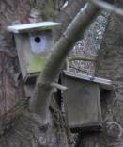
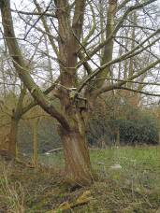Two (Tree Sparrow) Nest Boxes (G & H) Located along Long Hedge on tree by fence beside Lynsters Field. 2008: 1 empty & 1 attempted.
Nest Box G (GPS - N5137091 W030205) - The higher box. 2009: Blue Tit nested. 1 egg left. 2010: Had Tits nesting. 2011 & 2012 & 2013: Empty. 2014: No survey. 2015: Some moss but no nest. Roof should be repaired. 2016: Shaped nest but no egg shells. 2017: Roof was replaced but later blown off – now secured back on. Sign of a possible nest but covered in leaf and twig debris whilst the lid was off.

Nest Box H (GPS - N5137091 W030205) - The lower box. 2009: Attempted Blue Tit nesting. 2010: Had Tits nesting. 2011: Failed Tit attempt. 3 bodies. 2012: Wasp nest. (Box had fallen - refixed to tree in March 2013). 2013: Empty. 2014: No survey. 2015: Old (possibly 2014) nesting material but not a completed nest. 2016: Box ok. Nest started but not finished. 2017: Empty.

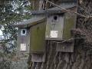
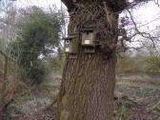Two (Tree Sparrow) Nest Boxes (I & J) Located between our stream in Paddock and Lynsters Field. 2008: Both with (Tit?) nests.
Nest Box I (GPS - N5137090 W030196) - The left-hand box. 2009: Empty. 2010: Had Tits nesting. 2011: Possible Tit nesting. 2012: Empty. (Box had fallen – re-fixed to tree in March 2013). 2013: Some nesting material but unsuccessful. 2014: No survey. 2015: Tit nest started but no cup. 2016: Empty. 2017: Empty.

Nest Box J (GPS - N5137090 W030196) - The right-hand box. 2009: Wasp's nest inside. 2010 Empty. 2011: Empty. 2012: Nesting attempted. 2013: Some nesting material but unsuccessful. 2014: No survey. 2015: Some nesting material but unsuccessful. 2016: Empty. 2017: Empty.

Nest Box K (removed in 2013) was a single box located by the Clubhouse next to the Ivy covered tree. 2008: Not recorded. 2009: Nest found (which may have been from a previous year). Gaping entrance hole. 2010: Fallen into disrepair. 2011: Removed. 2013: Replaced with Nest Box 57 at end of Lean-to (No usage each year in this location, so subsequently moved in 2017 – Now See Nest Box 57 for latest details).

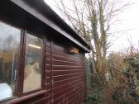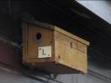
House Sparrow (Clubhouse) Nest Box L (GPS - N5137333 W030177) with 3 nesting chambers located on the Clubhouse under the eaves. 2008: Not recorded. 2009: All empty. 2010: 1 of 3 chambers used by Tits. 2011: 1 attempt, 2 empty. 2012: Not checked. 2013: Empty. 2014: No survey. 2015: Left chamber had evidence of (Tit) nesting. Middle chamber was empty. Right chamber had some old evidence of (Tit) nesting. 2016: Blue Tit reported using box on Open Weekend (14th and 15th May). Keith Pursall photographed Blue Tit exiting left chamber (as seen looking at front of boxes) 18th May and observed that Great Tits were using the other end of the box (right chamber). Left chamber: successful nesting – 1 egg and a chick skeleton. Middle chamber: Empty. Right chamber: a bit of material but no sign of a nest. 2017: Great Tit (feeding at nest box L on 29th Apr) and Great Tit (in Nest Box L on 1st & 7th May). As you look at the box from the road side, the right-hand and middle chambers had no sign of nesting. Only the left-hand chamber had the remains of a possible nest.
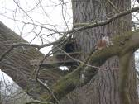Tawny Owl Nest Box M (GPS - N5137246 W030176) New for 2010 located on tree near 'dump' near corner of pathway towards D/D hide. 2010: Empty -unused. 2011 & 2012: Not used. 2013: Empty. 2014: No survey. 2015: No evidence of occupation or reported sightings. Consider repositioning. 2016: As last year. 2017: Box was felled by high winds earlier in the year and put back on the same branch but facing a different direction. A Jackdaw pair was seen near Owl nest box M on 8th Apr and later a Jackdaw was observed on a twig nest in Nest Box M on 15th & 23rd Apr. Jackdaws may have been successful. When the twiggy nest was removed during the survey, 3 squirrels swiftly emerged from the back of the box, giving Colin, who was up the ladder at the time, quite a shock as they leapt past him.

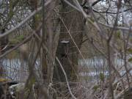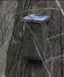
Treecreeper Nest Box N (GPS - N5137322 W030193) Located on tree in corner of Clubhouse feeding site. 2010: Empty so far. Unused. 2011 & 2012: Empty. 2013: Not checked. 2014: No survey. 2015: Empty. 2016: Found on the ground. Empty. Put back up on tree 10th Dec. 2017: Empty.

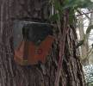
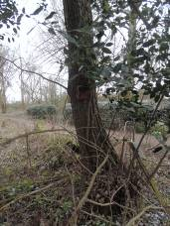Treecreeper Nest Box O (GPS - N5137296 W030168) New 2011, located on tree opposite path to bee hives. 2011: Empty. 2012: Empty. 2013: Box Missing? 2014: No survey. 2015: Located on tree on right-hand side, just inside entrance of New Woodland Walk. Nothing seen. 2016: Nothing seen / reported. 2017: Some leaves, possible nesting material but no reported activity for this box.

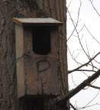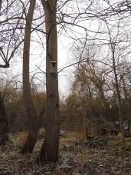Little Owl Nest Box P (GPS - N5137309 W030196) New 2011, located on tree behind Woodshed pond. 2011: Mossy nesting material - bird identity unknown. 2012 & 2013: Not checked. 2014: No survey. 2015: Needs Repair. 2016: Box found empty and broken on the ground – removed & repaired (including a new roof) ready for 2017. 2017: Needs long ladder. TO DO.

4 (Stock Dove or Duck) Nest Boxes (Q-T) originally all located on Marsh Lake island. New late spring 2011.
[2017: During April, there were several reported broods of Mallards ranging from 2 to 7, any of which may or may not have been from usage of these boxes. However no records of Mallard pairs residing in the boxes, or ducklings emerging were logged].
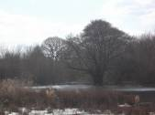Nest Box Q (GPS - TO DO ) - Viewed straight ahead from Sanctuary Hide. 2011 & 2012: No observed usage so far. 2013: One of these 4 boxes with nest (successful), the others empty. 2014: No survey. 2015: Not visible – may have blown down – to be checked. 2016: As 2015. 2017: Put back up in same location. No reported nesting, however an adult pair was seen on top of the box on 29th Apr with 4 ducklings seen in the water below this box. The next day broods of 6 and 7 where also seen in this area (but they may have come from elsewhere on the reserve).
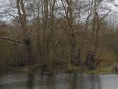
Nest Box R (Until 2017 - GPS - TO DO ) – Originally viewed c30 degrees right from Sanctuary Hide. 2011 & 2012: No observed usage so far. 2013: One of these 4 boxes with nest (successful), the others empty. 2014: No survey. 2015: Not visible – may have blown down – to be checked. 2016: Found on ground, repaired and moved to island (on taller tree) opposite the Teal Hide in 2017. 2017: (From 2017 - GPS - TO DO ) Now on island (on taller tree) opposite the Teal Hide. 2017: No observed prolonged usage other than initial interest by a pair of Mallard.
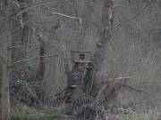New Duck Nest Box R2 (GPS - TO DO ) – New 2017 - On island opposite Teal Hide on 3’ stump. 2017: Mallards taking an interest in a new home when sited in March 2017 but no subsequent reports of box being used for nesting.

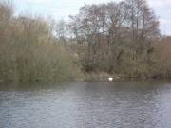Nest Box S (GPS - TO DO ) - Viewed from Shell and subsequently better seen from Long Hedge Hide. Left-hand box of S/T pair. 2011 & 2012: No observed usage so far. 2013: One of these 4 boxes with nest (successful), the others empty. 2014: No survey. 2015: No observed / reported usage. 2016: As 2015. 2017: As 2015/16

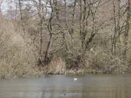
Nest Box T (GPS - TO DO ) - Viewed from Shell Hide. Originally the Right-hand box of S/T pair. 2011 & 2012: No observed usage so far. 2013: One of these 4 boxes with nest (successful), the others empty. 2014: No survey. 2015: No observed / reported usage. 2016: As 2015. 2017: (From 2017 - GPS - TO DO ) This box was moved to the ‘channel’ between the March Lake islands and is only just visible from the LH Hide through the trees in winter (when no leaves). The entrance cannot be seen. Not surveyed.

Little Owl Nest Box U (GPS - N5137160 W030177) New late 2011, located on Poplar c100 yards from Teal Hide. 2011: New box, open front. 2012: Not checked. 2013: Box Missing? 2014: No survey. 2015: Just leaves and some hairs, probably squirrel. 2016: Just leaves. 2017: Leaves and ‘grassy’ partial nest (not moss) – possible Blackbird sized nest. But no signs of completion of nest.

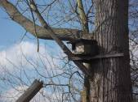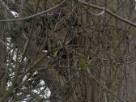
Kestrel Nest Box V (GPS - N5137138 W030175) New 2011, located near Sluice Hide when new but moved further right in 2012 after the original Poplar fell. 2011 & 2012: Not used. 2013: Empty. 2014: No survey. 2015: Not used. 2016: Not used. 2017: Leaves only (perhaps put there by Squirrels). No nest.

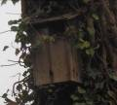
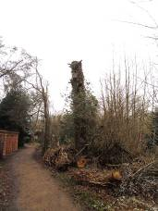Tawny Owl Nest Box W (GPS - N5137308 W030174) c20' up Ivy covered (road side) tree opposite Woodshed. Successfully used by Tawny Owls years ago nearly every year but not since. 2009 - 2013 inclusive: Not used. 2014: No survey. 2015: Not used. 2016: Not used. 2017: Not used. This tree has now been topped and cleared of Ivy. Very long ladder required to clear out this box for possible future reuse.

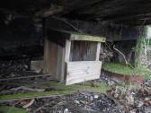Near Ground Nest Box X (GPS - N5137164 W030435) Located underneath Shell Hide. 2012 & 2013: Not checked. 2014: No survey. 2015: Box in excellent condition but appears never to have been used. 2016: As 2015. 2017: As 2015/16.

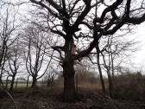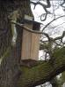Tawny Owl Nest Box Y (GPS – N??????? W??????) Located between our stream in Paddock and Lynsters on same tree as I & J (GPS - N5137090 W030196). 2016: New this year. No reported usage. 2017: No reported / observed usage. 2 squirrels emerged from the back as it was being looked into, giving Colin, who was up the ladder at the time, another shock. No nesting material.

NB: The 2017 bird nest box survey was carried out by Dave Simms and Colin Rowe (members of the Maple Lodge Conservation Society committee and work party) on January 6th and January 20th 2018. With thanks to members who recorded sightings and photographs throughout the year.

Bat Box Results for 2017
Maple Lodge is home to a number of species of bat.
2010-2014: We did not enter or disturb Bat Boxes due to lack of license.

2015: A group including Patty and Brian Briggs, who have licenses, surveyed the boxes this year. Those towards the Double Decker hide were all unused and damaged, so they were taken down. We were advised the entrances were too big (16mm max) and also advised on new sites for these by species and box type. When funds are available, they are to be replaced with new boxes.
One other suggestion was to put a double skin up under the Long Hedge Hide roof and drill holes in from the side to create a bat roosting site there.

2016: There are still 3 or old bat boxes in the old bandstand area. Additionally, the following new (purchased) boxes as below were added from 12th Nov 2016:

2017: As below, 7 boxes in place with a further 4 to be put up in 2018:

Bat Box No 1 (TQ03717 92534) – Added 12th Nov 2016. Located on the tree left of the Lean-to. 2017: Still here.

Bat Box No 2 (TQ03722 92353) – Added 12th Nov 2016. Located in tree area towards Double Decker Hide on left hand side of pathway. 2017: Still here.

Bat Box No 3 (TQ03772 92396) – Added 12th Nov 2016. Located in the Plantation near the left hand edge of the path towards the Pudding Stone. 2017: Still here.
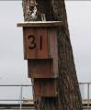
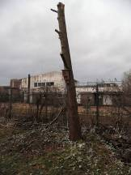Bat Box No 31 (TQ03785 92335) – ‘Kent Box’ made in 2017. Located in Comma Corner near to the Pudding Stone. 2017: Still here.

Bat Box No 4 (TQ03xxx 92xxx) – Added Nov or Dec 2016. Located beside Long Hedge Hide (facing end panel on right hand side). 2017: Still here.

Bat Box No 5 (TQ03646 92148) – Added 12th Nov 2016. Located on the Oak tree by the Barn Owl Flower Meadow (as per Bird nest box 11). 2017: Still here.

Bat Box No 6 (TQ03573 92184) – Added 12th Nov 2016. Located near to Kestrel box 24 facing Barn Owl Meadow. 2017: Still here.

Bat Box No 7 (TQ03xxx 92xxx) – ‘Kent Box’ – Made Oct 2017. To be put up in 2018.

Bat Box No 8 (TQ03xxx 92xxx) – ‘Kent Box’ – Made Oct 2017. To be put up in 2018.

Bat Box No 9 (GPS - N5137227 W030215) – ‘Kent Box’ – Made Oct 2017. Put up in 2018 above the upper floor window slots of the new Double Decker hide.

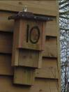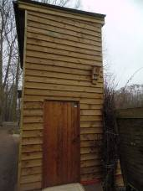Bat Box No 10 (GPS - N5137227 W030215) – ‘Kent Box’ – Made Oct 2017. Put up in 2018 above the top right hand corner of the door to the new Double Decker hide.

